Experiment/Practical 9 Naïve Bayes

Title: Implementation of Naive Bayes for Classification
Aim: To implement and understand the Naïve Bayes algorithm for classification tasks and
evaluate its performance on a given dataset.
Objective: Students will learn
- The classification mechanism of Naive Bayes.
- The mathematical formulation and working principle of Naive Bayes.
- Evaluating the model's performance using relevant metrics
- Comparing Naive Bayes with other classification models

Problem statement
Use the given dataset(s) to demonstrate the application of the Naive Bayes algorithm for classification. The task is to classify the data points into different classes based on features and understand the feature independence assumption.

Explanation/Stepwise Procedure/ Algorithm:
- Give a brief description of the Naïve Bayes
Naïve Bayes is a family of simple “probabilistic classifiers” based on Bayes’ Theorem, with the key assumption that features are conditionally independent given the class label. This assumption, though sometimes unrealistic in practice, simplifies computations significantly and allows the model to scale efficiently to large datasets. Naïve Bayes is widely used for text classification (e.g., spam detection) and various other domain-specific classification tasks
- Give mathematical formulation (Bayes’ Theorem)
P(C∣X)= P(X∣C)×P(C)​/ P(X)
- • P(C∣X): Posterior probability of class CCC given the predictors/features XXX.
- • P(X∣C)P(X \mid C)P(X∣C): Likelihood, the probability of observing XXX given that the class is CCC.
- • P(C)P(C)P(C): Prior probability of class CCC.
- • P(X)P(X)P(X): Evidence or the probability of observing XXX under all possible classes.

- Assumption :
Feature Independence Assumption: All features are assumed to be independent from each other given the class. While this is often violated in real-world data, Naïve Bayes still performs remarkably well in many applications
- Describe types of Naïve Bayes Models (Gaussian, Multinomial, Bernoulli)
- Gaussian Naïve Bayes
Assumes the continuous features follow a Gaussian (normal) distribution.
Often used when features are real-valued (e.g., sensor data, continuous measurements).

- Multinomial Naïve Bayes
Best suited for discrete data, especially word counts or frequency counts in text classification.
Commonly used in document classification tasks (bag-of-words model).

- Bernoulli Naïve Bayes
Ideal for binary/boolean features (presence or absence).
Used for text classification when using binary term occurrence features (e.g., spam detection).

- Write the importance of the Naïve Bayes in the classification task
Simplicity & Speed: Easy to implement and computationally efficient, especially for large datasets.

Handles High-Dimensional Data: Performs well even with many features, often encountered in text classification.

Robust to Irrelevant Features: The independence assumption mitigates issues with redundant features.

Works Well with Small Training Data: With strong assumptions, it can generalize quickly even with limited data.

- Mention applications of the Naïve Bayes.
Spam Filtering: Classify emails as spam or non-spam by word occurrences.
Sentiment Analysis: Classify text as positive, negative, or neutral.
Medical Diagnosis: Predict disease probability based on various symptoms.
Document Classification: Assign category labels to news articles or documents.
Real-time Prediction: Rapid classification in streaming data scenarios.

- Brief explanation of performance metrics (e.g., accuracy, precision, recall, f1-score, confusion matrix, cross-validation)
Accuracy

Accuracy is the proportion of all classifications that were correct, whether positive or negative. It is mathematically defined as:

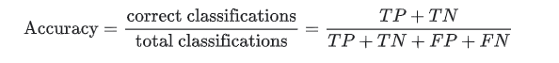

Recall, or true positive rate

The true positive rate (TPR), or the proportion of all actual positives that were classified correctly as positives, is also known as recall.

Recall is mathematically defined as:

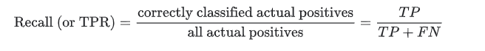

False positive rate

The false positive rate (FPR) is the proportion of all actual negatives that were classified incorrectly as positives, also known as the probability of false alarm. It is mathematically defined as:

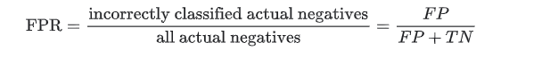

Precision

Precision is the proportion of all the model's positive classifications that are actually positive. It is mathematically defined as:

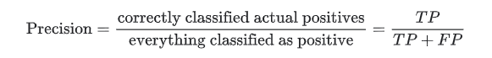

- Add necessary figure(s)/Diagram(s)
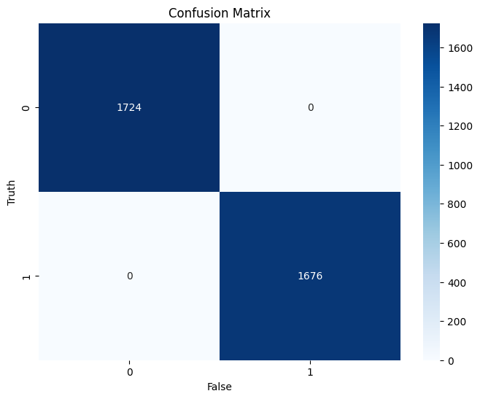
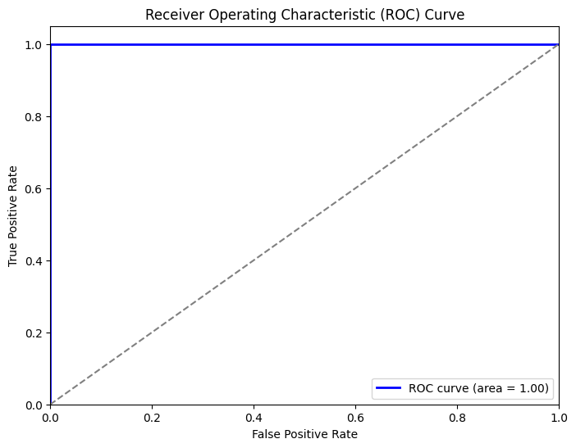
Conclusion:
Naïve Bayes provides a simple yet powerful method for classification by applying Bayes’ Theorem with the (naïve) assumption of feature independence. Despite this assumption being somewhat restrictive, Naïve Bayes often performs competitively, especially on high-dimensional data like text.
Impact of Feature Independence Assumption
- Model Simplicity: The assumption drastically simplifies the computations, making Naïve Bayes easy to train and fast to predict.
- Decent Performance: Even when independence is not strictly true, the model can still achieve good results.
- Possible Misclassification: Highly correlated features can sometimes degrade performance because the assumption treats them as independent.
Overall, Naïve Bayes serves as a reliable baseline classifier due to its efficiency, interpretability, and often surprisingly good performance across many domains.

